**Quiz Application Screenshots –**

Below are the screenshots of my overall project structure which consists of 8 quizzes –

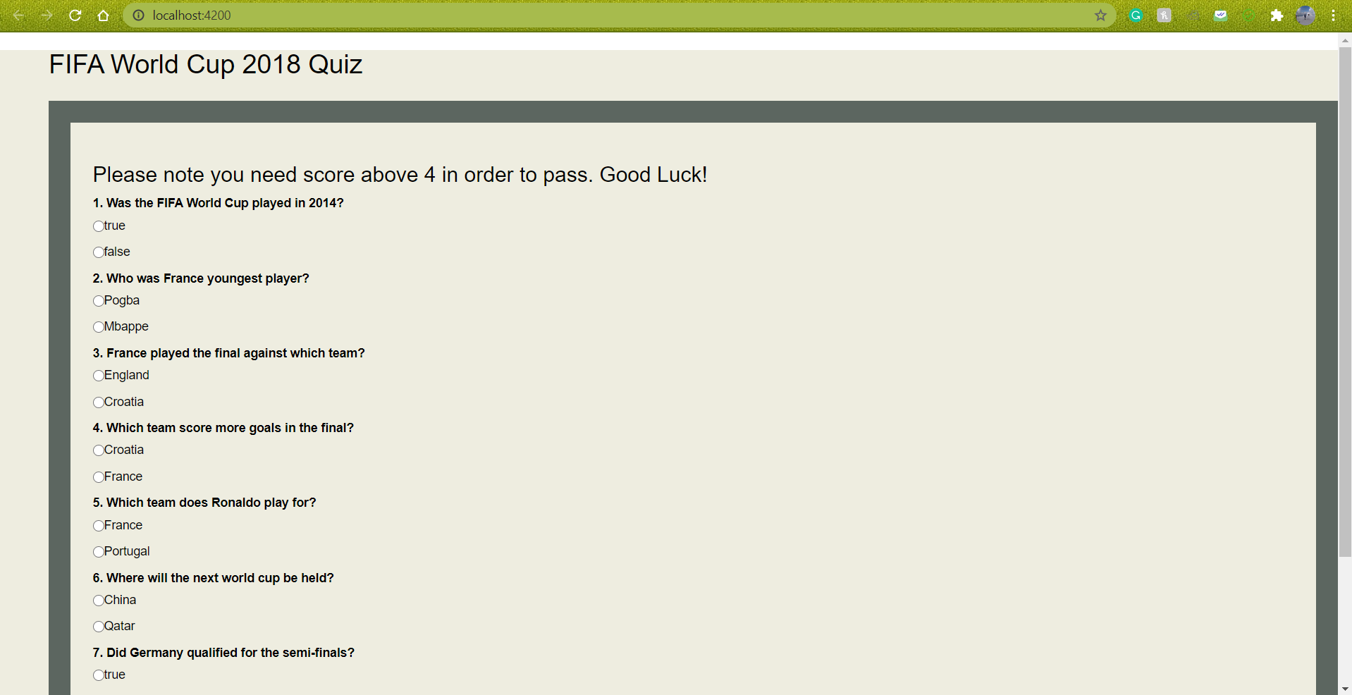

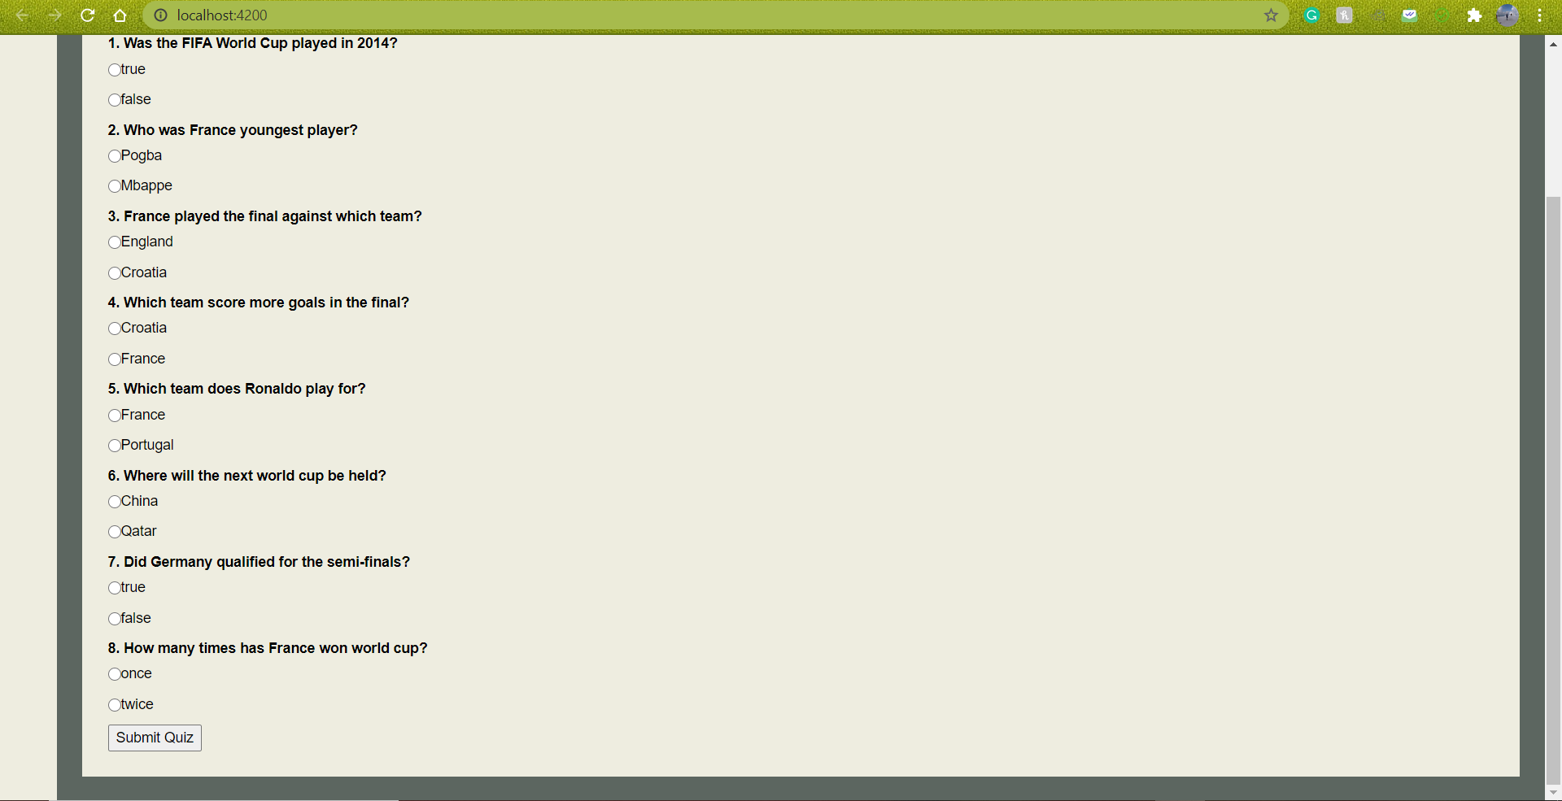

I have selected few questions right and some wrong. When I submit it, it gives the output like this –

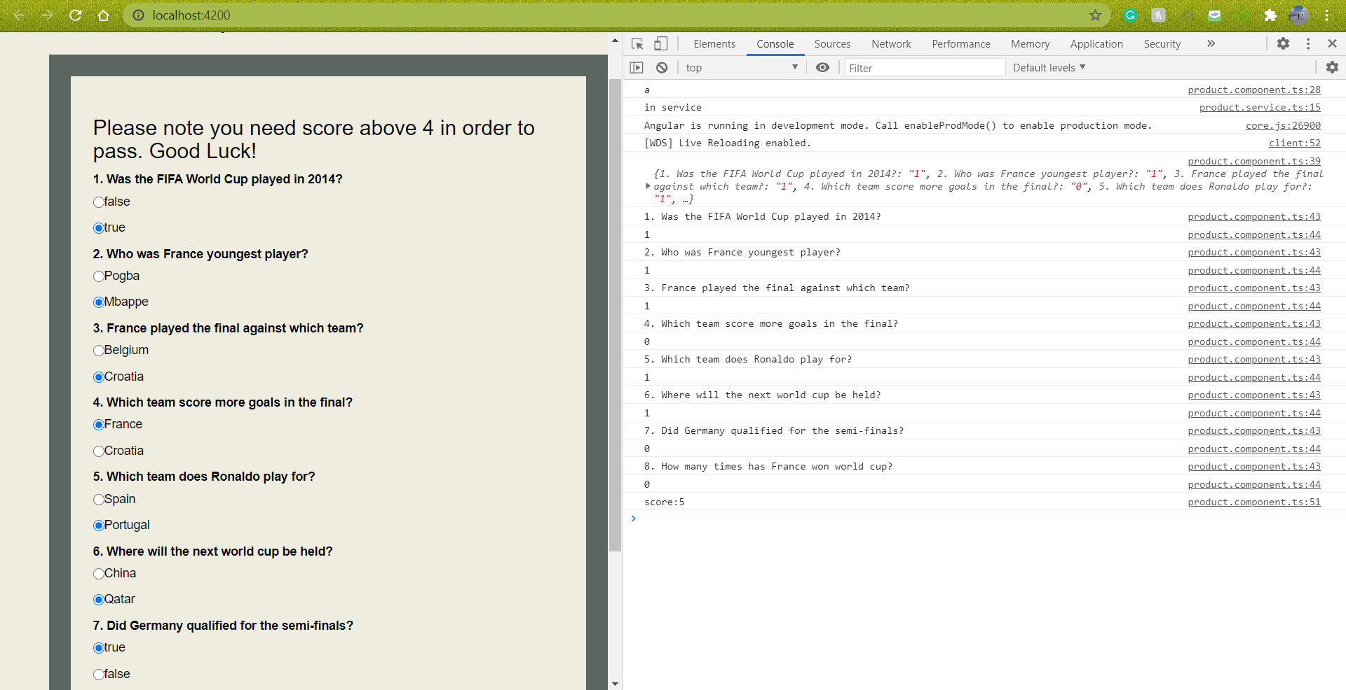

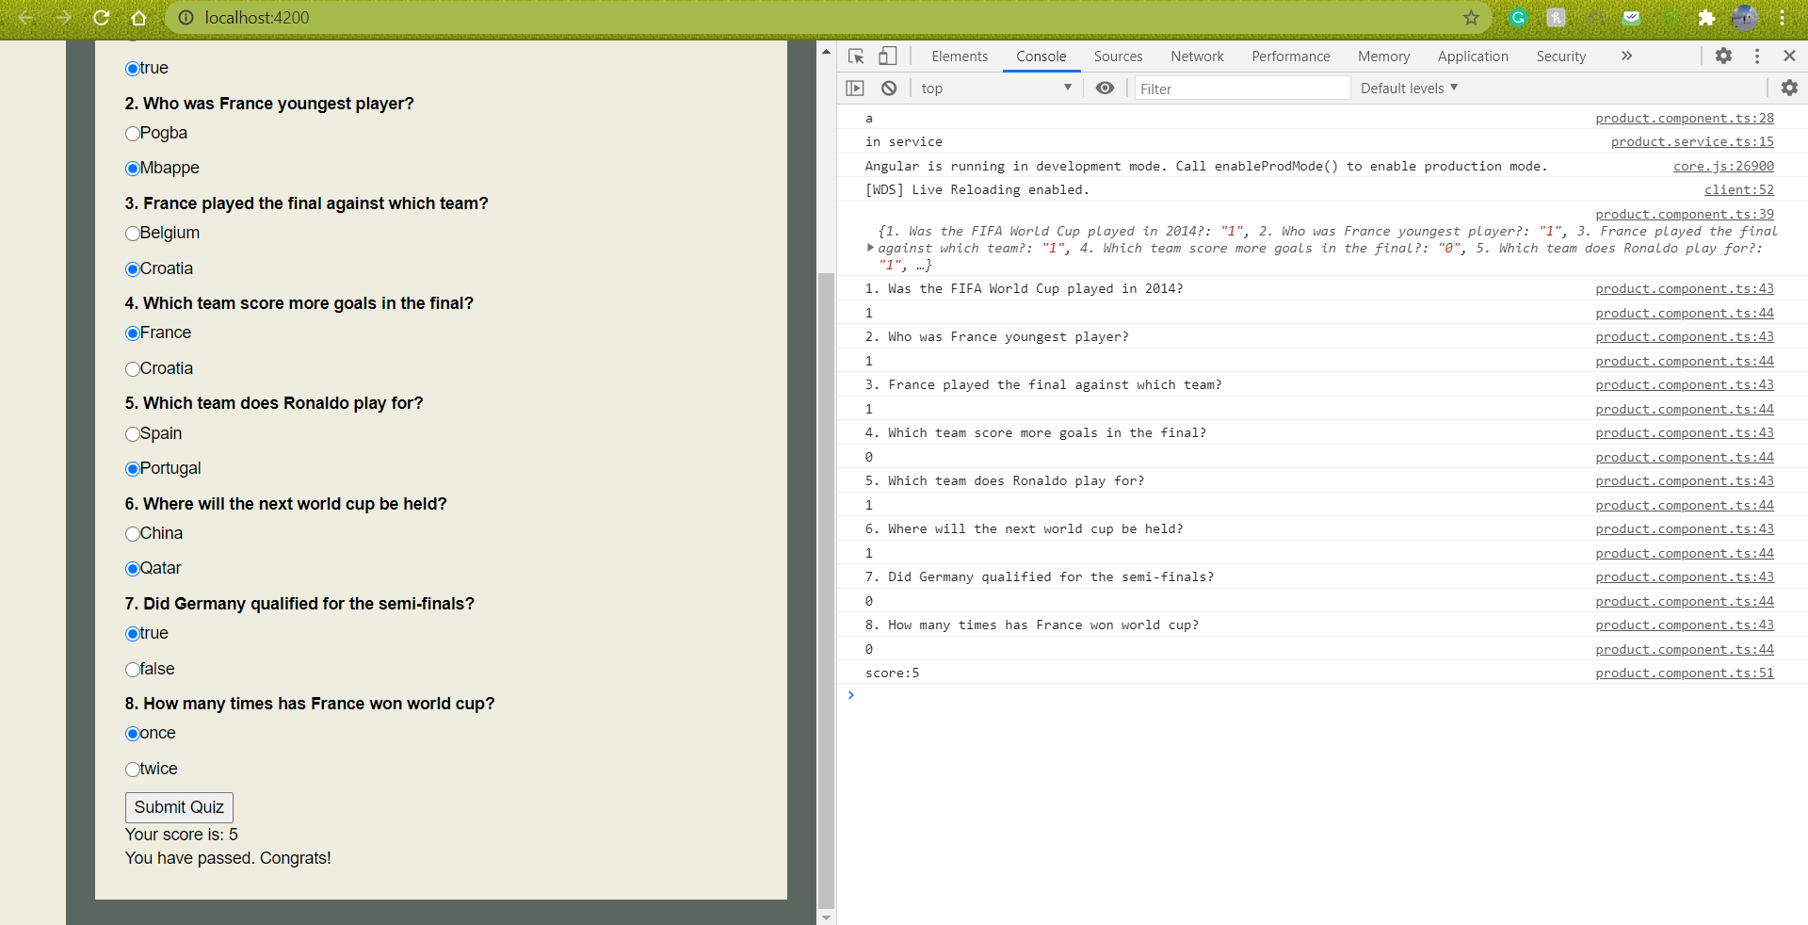

As you can see above, I have 5 correct answers and 2 wrong. I have passed the passing score which should be above 4.

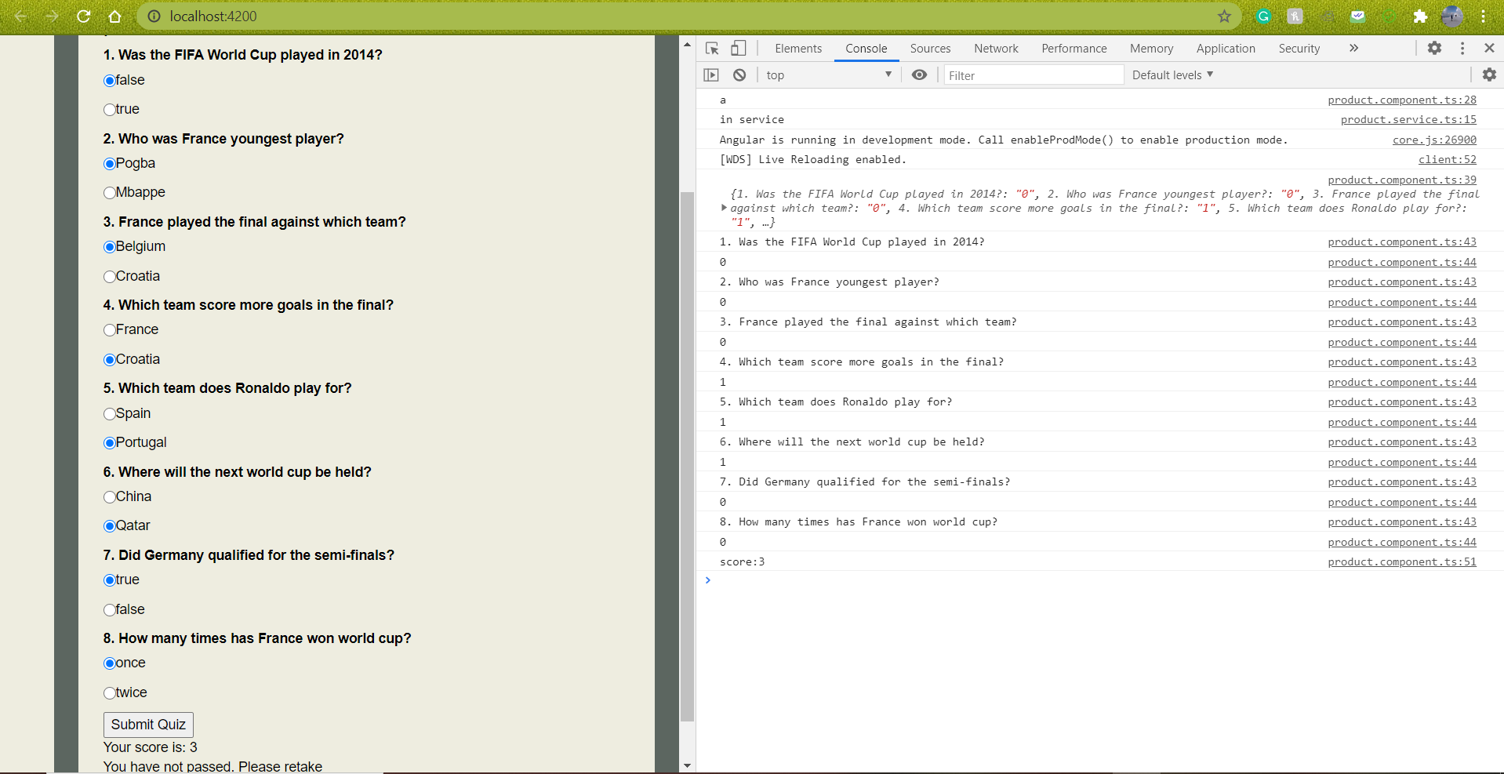

This is another example where I have answered 5 wrong answers and 2 correct. Hence, it says that I need to retake the quiz.